*에덴 콘스탄티노*

*학번:5266484*

**Main Form**

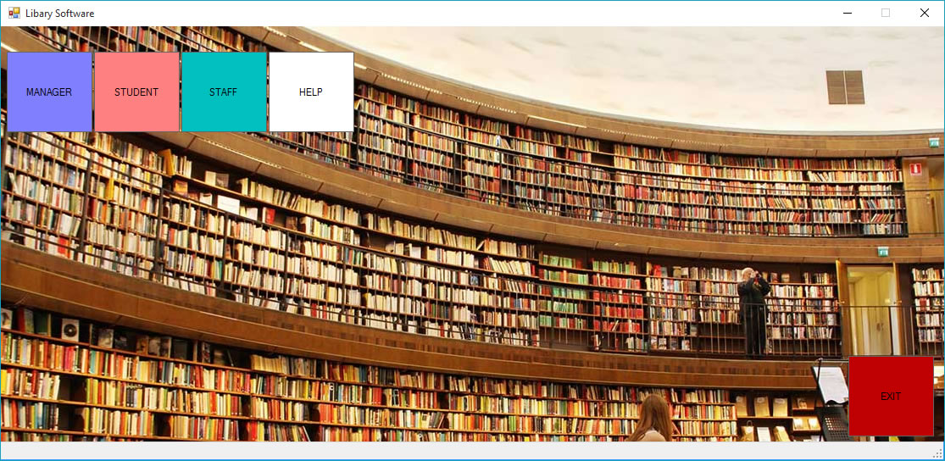

**Student Login Form**

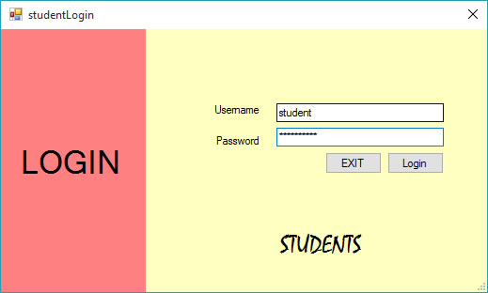

**Student Form**

